**Encrypt & Decrypt App**

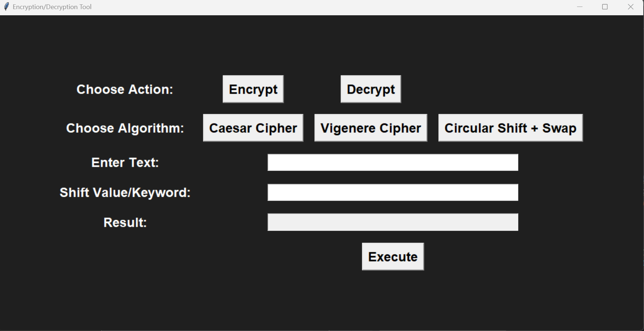

The main goal of this project is to develop a well-presented encryption & decryption app using python. It mainly employed symmetric cryptography, such as Ceaser Cipher, Vigenère Table, and Circular Shift + Swap. The purpose of this software is to be as of assistance to students and be used an educational tool. It was built using python classes, functions, built-in functions, loops, if-statements, and GUI.